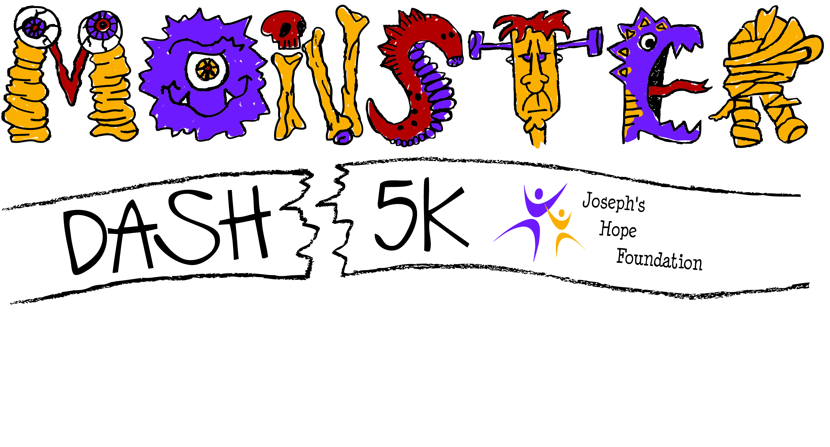

**Saturday, October 24, 2015, NCM Motorsports Park, Bowling Green, KY**

**Sponsorship Form**

**Yes, I agree to sponsor the Monster Dash 10K Run, 5K Run/Walk to benefit Joseph’s Hope Foundation and their mission for adoption support and orphan care.**

**Organization Name: __________________________________________________________________**

**Contact Person: ______________________________________________________________________**

**Address: _______________________________________________________________________**

**Phone: _______________________________ email: __________________________________**

*Please email company/organization logo (in vector format if possible, also in jpg and pdf files) to:* [*benjie.harmon@wku.edu*](mailto:benjie.harmon@wku.edu)

**Sponsorship Levels – please check level of support**

**C:\Program Files (x86)\Microsoft Office\MEDIA\CAGCAT10\j0305493.wmf _________Pumpkin Level Sponsor - $1,000**

* **Organization logo on race t-shirt, in pumpkin level section**
* **Advertising signage on-site at race location (and on pumpkin level signs on race course)**
* **Logo to be included on Joseph’s Hope Foundation website (**[**www.joeshope.org**](http://www.joeshope.org)**) and Facebook page.**
* **Sponsorship acknowledgement on media interviews.**

**C:\Users\Gina\AppData\Local\Microsoft\Windows\Temporary Internet Files\Content.IE5\ZG54FCHO\MC900435919[1].wmf ________Goblin Level Sponsor - $500**

* **Organization logo on race t-shirt, in goblin level section**
* **Advertising signage on-site at race location on (and on goblin level signs on race course)**
* **Logo to be included on Joseph’s Hope Foundation website and Facebook page**

**C:\Users\Gina\AppData\Local\Microsoft\Windows\Temporary Internet Files\Content.IE5\WEIKRHTL\MC900232171[1].wmf ________Ghost Level Sponsor - $250**

* **Organization logo on race t-shirt, in ghost level section**
* **Advertising signage on-site at race location (on ghost level signs)**
* **Logo to be included on Joseph’s Hope Foundation website and Facebook page**

**Please make all check payable to Joseph’s Hope Foundation and mail to: Benjie Harmon, 183 Stephanie Street, Bowling Green, KY 42104**